# Range Shifts: How Marine Taxa Track A Shifting Climate (Answer key)

Adapted from [Marine Taxa Track Local Climate Velocities](https://science.sciencemag.org/content/341/6151/1239)

## [Link to the visualization](https://huckley.shinyapps.io/RShiny_RangeShifts/)

## [Link to TrEnCh-Ed](https://trench-ed.github.io/#)

## Objectives

* Develop understanding of the global climate and microclimate forces behind range shifting.
* Analyze cause and effect plots and their biological reality.
* Use historic survey data to predict intuitive and unintuitive range shifting.
* Gain an understanding of marine range shifts, climate velocities, and thermal envelopes.

## Core concepts -- *BioCore*

* Physiology: Evolution
* Ecology and Evolutionary Biology: Evolution
* Ecology and Evolutionary Biology: Transformations of Energy and Matter
* Physiology: Systems
* Ecology and Evolutionary Biology: Systems

## Instructions & Questions

### Background

### First, read the introduction of the visualization and answer the following background questions.

1. How are thermal envelopes and climate velocities related?  
   The movement of a thermal envelope is referred to as its climate velocity.
2. Come up with a reason why a local climate velocity may be in an unintuitive direction.   
   For example, the microclimate might be located near a jetstream or strong ocean current. These strong local conditions can “overrule” the general oceanic climate velocity north and deeper, and instead have its climate velocity be south or shallower. Many things can influence this local climate velocity.   
   Another example could be a near-shore microclimate under an increasingly aerosol-polluted sky. Certain aerosols are cooling the Earth under them, and near-shore microclimates may have a climate velocity moving shallower as the microclimate cools due to increasing pollution.   
   Another example could be a large iceberg which migrates atop a fish colony. This now-cooling microclimate may cause the fish colony’s thermal envelope to move in a direction different from the global trend.   
   A final example is a fish colony that is landlocked to the north and connected to a larger body of water to the south. It’s thermal envelope may move towards the “cooler” open waters towards the south.

### Thermal envelopes and taxon shifts

Ensure the taxa filter is set to “All.”

1. Think about the background information:
   1. What directions of depth and degrees North are the intuitive directions for populations to be moving due to climate change?   
      Deeper and positive degrees North.
   2. Does the data support your intuitive guesses? Why or why not?  
      It doesn’t support the guesses since only about half of the species are moving deeper and towards the North.
2. Look at the latitude (˚N/yr) plot and spot the datapoint at (0.04, 0.28). Hover over the point to retrieve species information and search online to learn a bit about the species (Wikipedia will work). What is its species name? Does what you learned about the species help explain its position on the graph? Briefly explain.  
     
   The name is *Anarhichas denticulatus*, and it’s a fish species. The range of this species shifted due North a lot faster than the shift in it’s thermal envelope.
3. Look at the depth (m/yr) plot and spot the datapoint at (3.76, 0.48). Remember, a positive depth shift means a move to deeper waters. Again, hover over the point to retrieve species information and search online to learn a bit about the species (Wikipedia will work). What is its species name? Does what you learned about the species help explain its position on the graph? Briefly explain.  
     
   The name is *Coryphaenoides rupestris*, and it’s a fish species. The species shifted their range deeper at a much slower rate than its thermal envelope.

1. For each of the scenarios below, List the species names and xy-coordinates of a data point corresponding to each of the following scenarios on the Depth or Latitude plot:

a. A population that “overshot” its thermal envelope (i.e. a population that has a range shift greater than its climate velocity).  
  
Example should have the absolute value of y coordinate > absolute value of x coordinate.

b. A population that is tracking its thermal envelope in the intuitive direction.  
  
Example should have the positive x and y coordinate values that are about equal.

c. A population that is tracking its thermal envelope in the unintuitive direction.   
  
Example should have the negative x and y coordinate values that are about equal.

1. What is a possible outcome of a population **not** shifting with the climate velocity of its thermal envelope?  
   The population can experience lack of oxygen in water from increased temperatures, which can disrupt their growth and reproduction and eventually go extinct.

or

The population can evolve to be more tolerant of warmer water.

1. What is a possible reason why a population is **not** shifting with the climate velocity of its thermal envelope?  
   The species cannot move fast enough to keep up with the climate velocity due to

physical constraints.

or

The species cannot move due to geographic constraints.

or

The species quickly acclimated to the change in water conditions, which made it unnecessary for the population to shift their range.

etc.

### Taxa-specific shifting

Ensure you are on the depth plot for the following questions.

1. Set “Select taxa” = “Fish” and “Select fish” = “Sharks”. Leave “Region” = “All”. Take a screenshot of this plot.  
   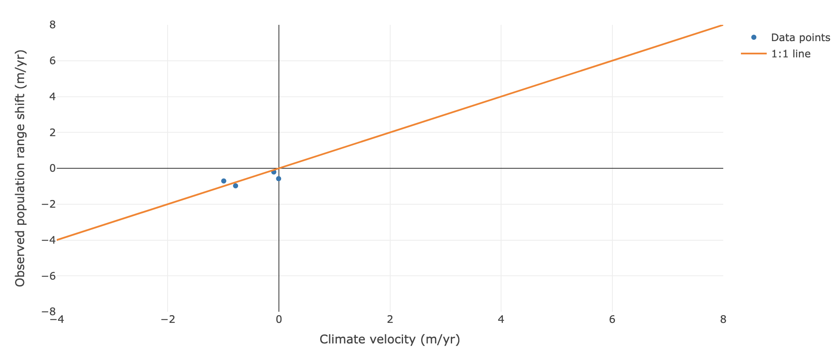
2. Set “Select taxa” = “Brittle stars.” Leave “Region” = “All”. Take a screenshot of this plot.  
   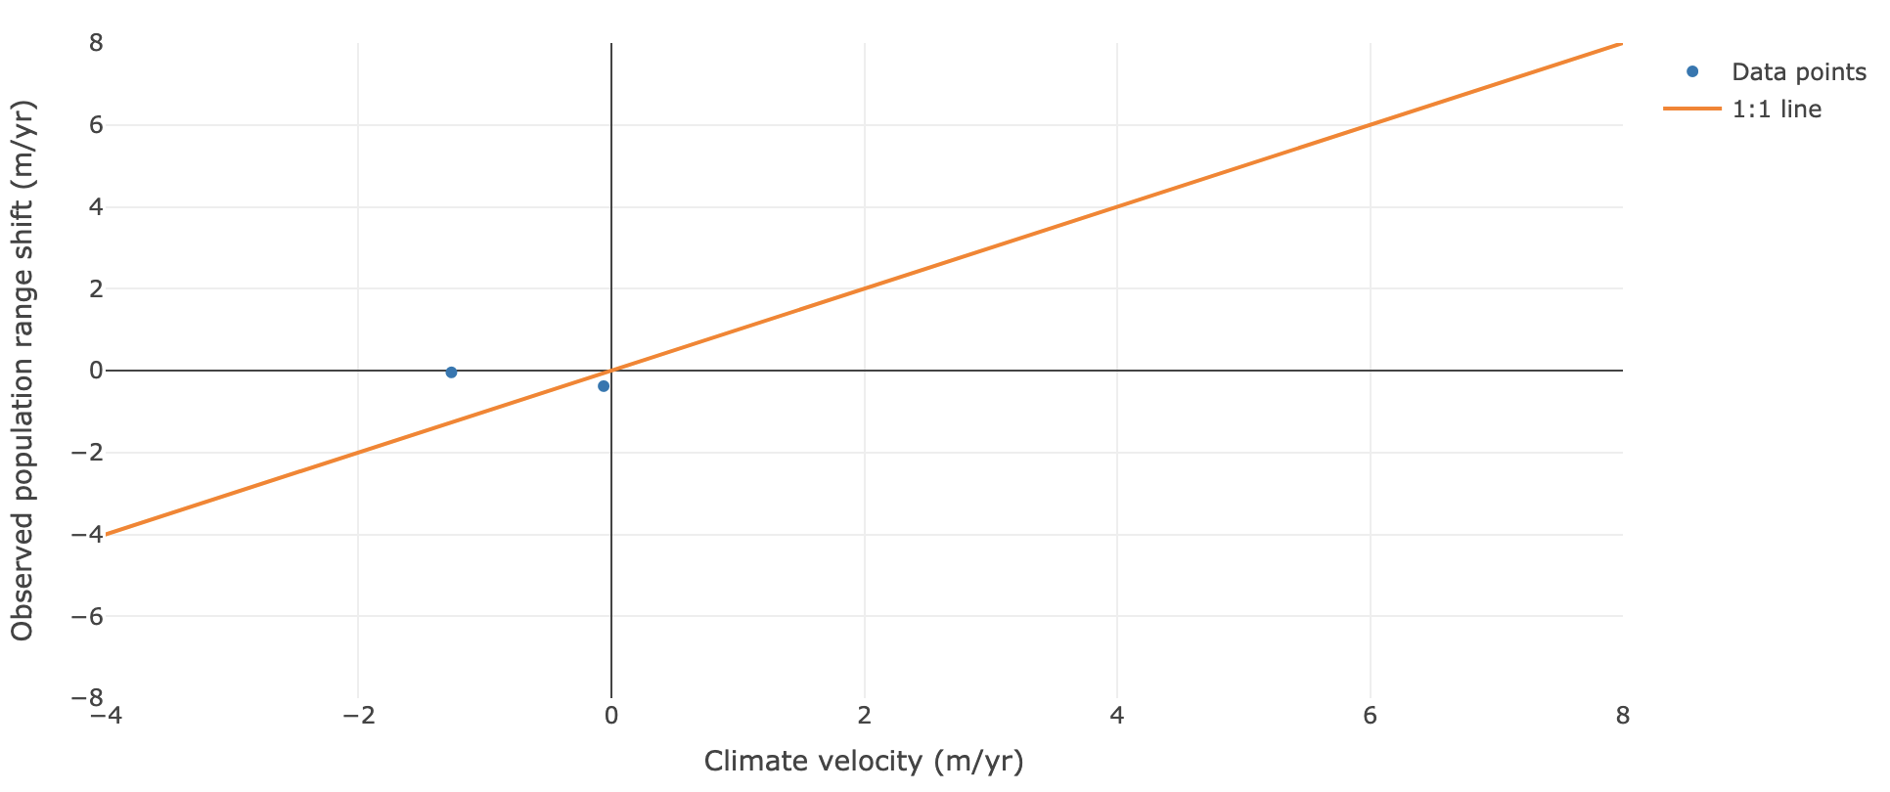
3. Look up brittle stars to understand this data. What differences do you see between these two taxa groups? Hypothesize why this might be the case.  
   The sharks are more or less shifting as fast as the climate velocity while the brittle stars are shifting much slower than the climate velocity. One hypothesis is that the brittle stars are limited in their mobility compared to the sharks, which makes it harder for them to keep up with the shift in the thermal envelope.

Now, switch to the latitude plot for the following questions. Set “Select taxa” = “Fish” and “Select fish” = “All”.

1. Set “Region” = “Newfoundland”. Take a screenshot of this plot. Are the majority of fish populations in the positive quadrant of the graph (top right) or negative quadrant of the graph (bottom left)? What does this indicate?  
   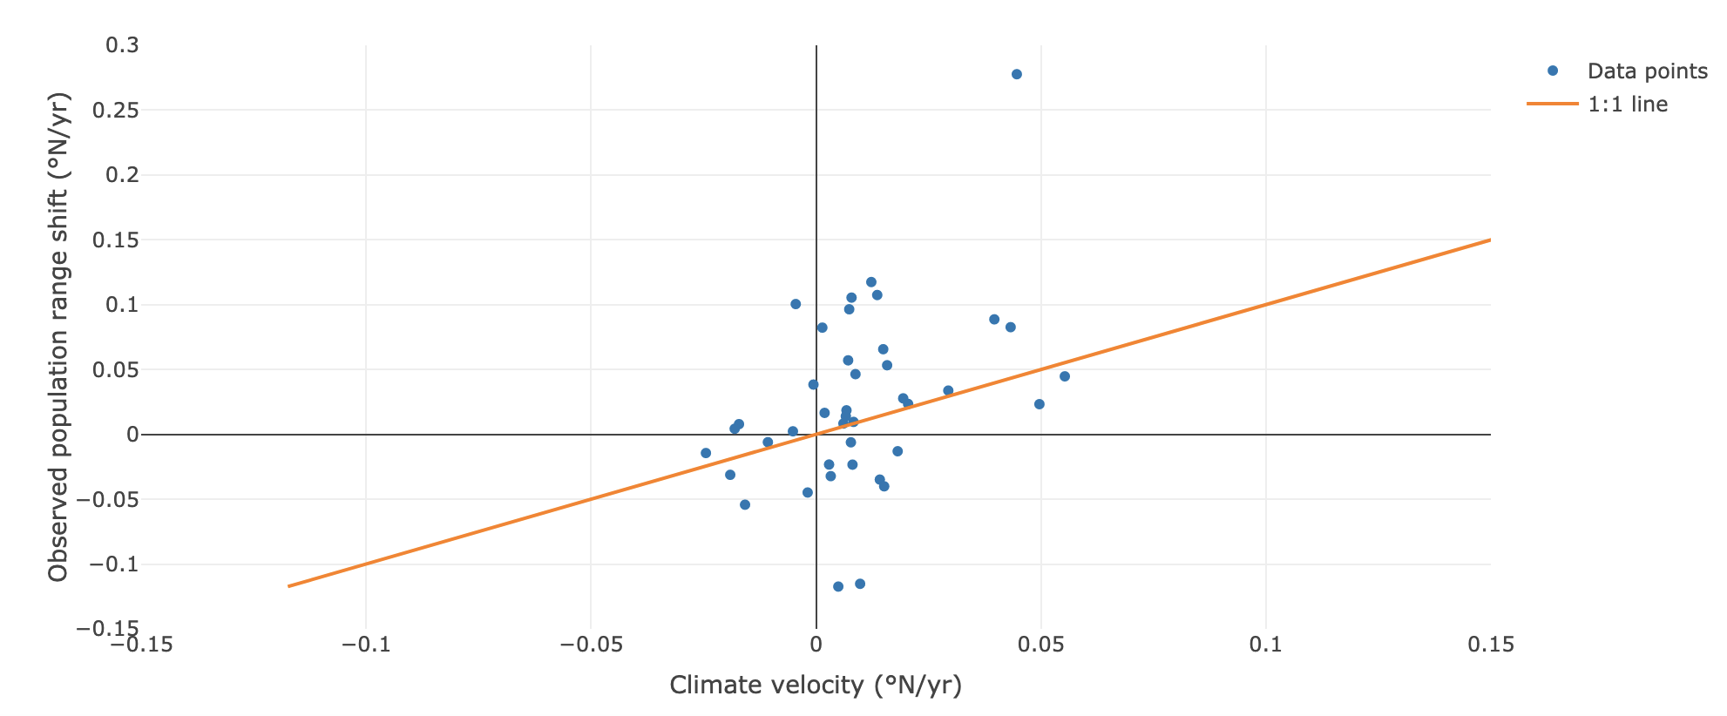  
   The negative quadrant. They are shifting northward.
2. Set “Region” = “Gulf of Alaska”. Are the majority of fish populations in the positive quadrant of the graph (top right) or negative quadrant of the graph (bottom left)? What does this indicate?  
   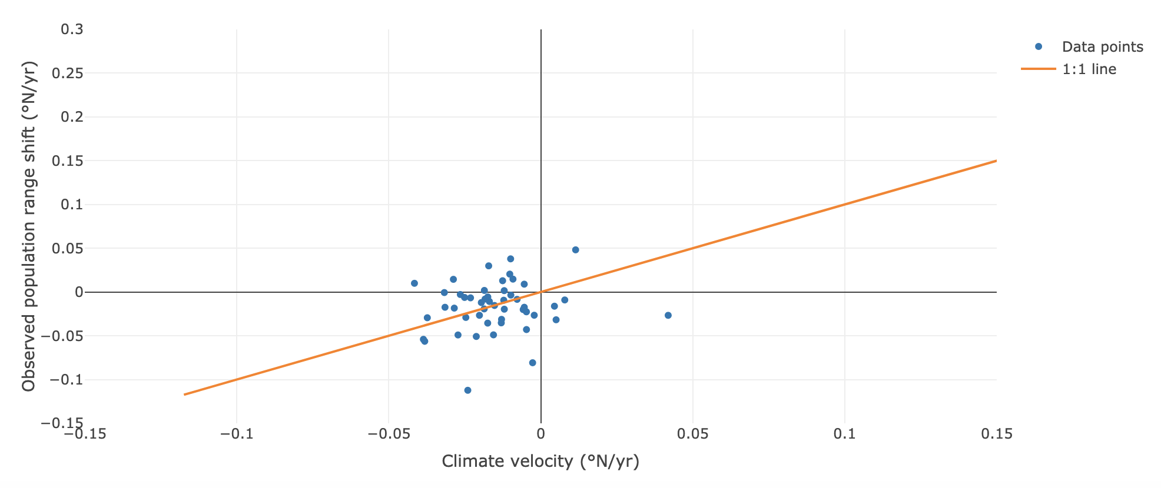  
   The negative quadrant. This indicates they are shifting south.
3. Look up the locations of these two regions. Hypothesize why the climate velocity of these locations are shifting in different directions. What about the Gulf of Alaska might cause it’s fish populations to have southern climate velocities?

The ocean off of Newfoundland has a direct water path north to the polar region, allowing the climate velocity to travel north to cooler waters. However, the Gulf of Alaska has land (Alaska) to its north, and waters must travel southwest before there is a water channel to the polar region.